MODULE 2

QUE1
https://www.hackerrank.com/challenges/conditional-statements-in-c/problem?isFullScreen=false

CODE
int main()
{
char* n_endptr;
char* n_str = readline();
int n = strtol(n_str, &n_endptr, 10);

if (n_endptr == n_str || *n_endptr != '\0') { exit(EXIT_FAILURE); }

// Write Your Code Here
if(n == 1)
printf("one\n");
else if(n == 2)
printf("two\n");
else if(n == 3)
printf("three\n");
else if(n == 4)
printf("four\n");
else if(n == 5)
printf("five\n");
else if(n == 6)
printf("six\n");
else if(n == 7)
printf("seven\n");
else if(n == 8)
printf("eight\n");
else if(n == 9)
printf("nine\n");
else
printf("Greater than 9\n");

return 0;
}

OUTPUT
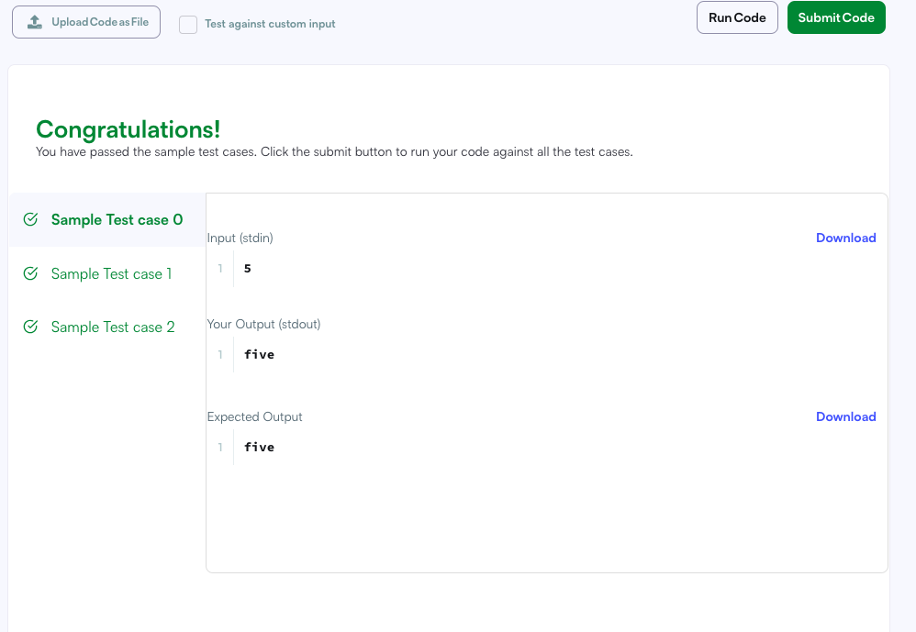

QUE2

https://leetcode.com/problems/smallest-even-multiple/
CODE
int smallestEvenMultiple(int n) {
if (n%2==0)
return n;
else
return n*2;

}

OUTPUT
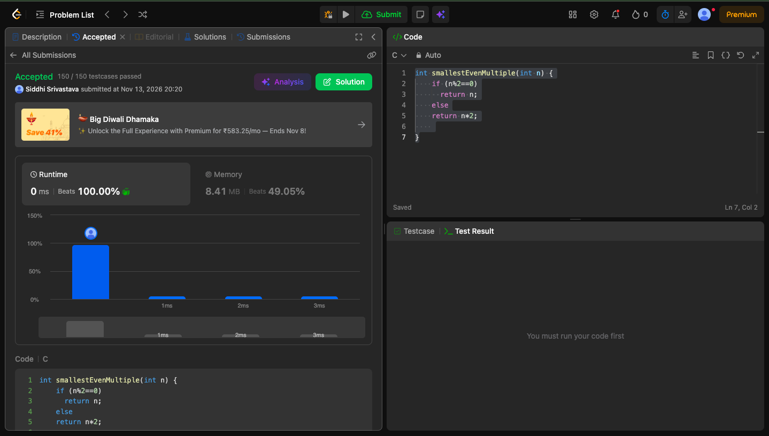

QUE 3

https://www.hackerrank.com/challenges/grading/problem
CODE
int* gradingStudents(int grades_count, int* grades, int* result_count) {
*result_count = grades_count;

int *result = malloc(grades_count * sizeof(int));

for (int i = 0; i < grades_count; i++) {
if (grades[i] < 38) {
result[i] = grades[i];
}
else {
int next = ((grades[i] / 5) + 1) * 5;

if (next - grades[i] < 3) {
result[i] = next;
}
else {
result[i] = grades[i];
}
}
}

return result;

}

OUTPUT
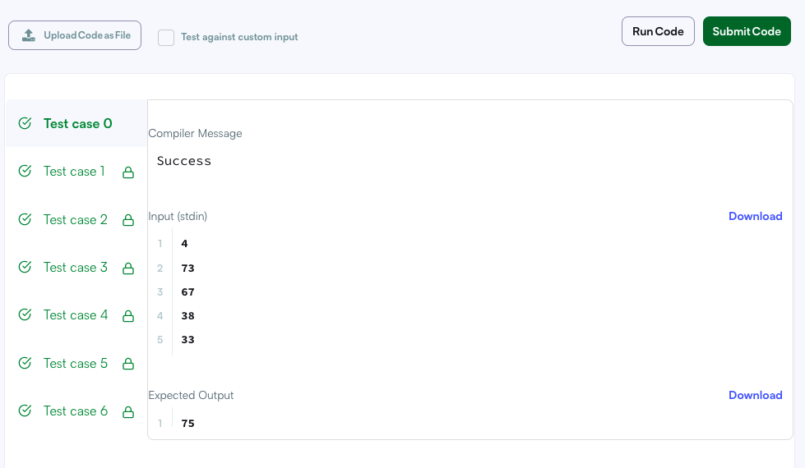

QUE4
https://www.hackerearth.com/practice/basic-programming/input-output/basics-of-input-output/practice-problems/algorithm/roy-and-profile-picture/

CODE
#include <stdio.h>

int main(){

int L, N, W, H;

scanf("%d", &L);
scanf("%d", &N);

for(int i = 1; i <= N; i++)
{
scanf("%d %d", &W, &H);

if(W < L || H < L)
printf("UPLOAD ANOTHER\n");

else if(W == H)
printf("ACCEPTED\n");

else
printf("CROP IT\n");
}

return 0;
}

OUTPUT
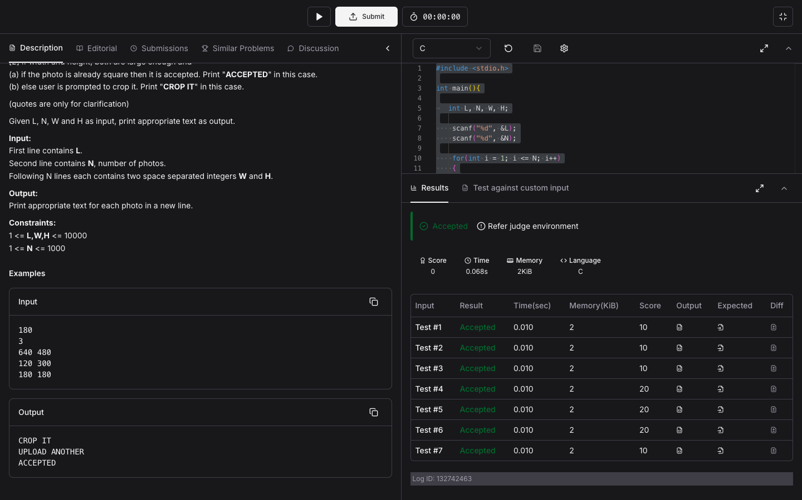

QUE5
https://www.hackerrank.com/challenges/fizzbuzz/problem

CODE
#include<stdio.h>
int main()
{
int i;
for(i=1;i<=100;i++)
{
if(i%3!=0 && i%5!=0) printf("%d\n", i);
if(i%3 == 0 && i%5!=0)printf("Fizz\n");
if(i%5 == 0 && i%3!=0)printf("Buzz\n");
if(i%5 == 0 && i%3==0)printf("FizzBuzz\n");
}
}

OUTPUT



